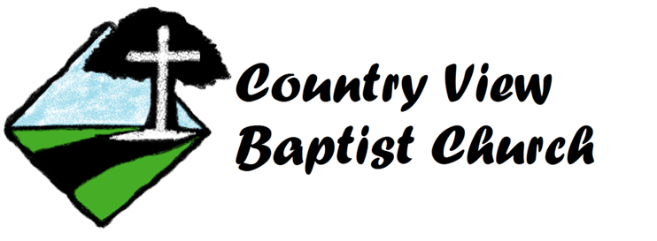
2478 N. Colorado St.
Ulysses, KS. 67880
Phone: 620-356-4376
E-mail: cvbch@pld.com
Fax: 620-424-4023
Website: countryviewbc.com
Pastor, Sam Bynum
Assistant Pastor, Jarrod Tunnell

Missionary Profile for the Country View Baptist Church

MISSIONARY CONTACT INFORMATION
Name (type or print): ______________________________________________________
Field/Country to which you are called: __________________________________
Email: _____________________________________ Phone #: (_______) ________-______________

SPONSORING CHURCH/PASTOR CONTACT INFORMATION
Sponsoring Church: ______________________________________
Address: _______________________________ City: _____________________ State: ______ Zip: _________
Pastor’s Name: ______________________________________________________
Email: ______________________________________________________
Phone #: (_______) ________-______________

These QUESTIONS are not intended to be offensive, we just want to make sure we understand where you stand on certain doctrines taught in the Bible that we feel very strongly about.

- Please share your testimony of salvation.

- Do you believe that for any reason anyone could lose his or her salvation?

- How would you define the word “church” as used in the New Testament and when did it start?

- Are you subject to the authority of your sponsoring church or another organization outside the local church?

- How long have you been a member of your sending church and what positions of service and leadership have you held in your home church?

PERSONAL QUESTIONS

- How many are traveling with you?
- What Accommodation do you need?
- How many nights do you need to stay with us?
- Our preference for your presentation is Sunday evening at 6:00 p.m. Otherwise we are flexible.
- Do you need DVD, Power Point, or other programs to help with your presentation?

